Monolith Architecture:
- All the modules are present in a single codebase.
- All the modules are built, tested, run and deployed together.
- A shared DB is used by all the modules.
- If an issue comes anywhere in the codebase, the entire application will crash.
- Problems:
  - Single point of failure
  - Deployment bottleneck: if we wish to add credit card functionality in the payment module, we will have to redeploy the entire application.
  - No individual scaling: our auth module gets a traffic of 20M users but the payments module only gets a traffic of 2M users, still we will have to scale the entire application to 20M users which will increase the cost unnecessarily.
Microservices:
- All the modules are served as separate services, called microservices.
- They can be built, tested, run, and deployed independently.
- Each service may have its own dedicated database and entry point (index.js).
- They easily solve the above 3 problems present in monolith architecture.
- Migrating from Monolith to Microservices:
  - Not a one day activity, we don’t migrate the system as whole, we go module by module.
  - The first step is to understand your monolith and analyze all the modules.
  - Then identify the high impact areas: the modules that are most susceptible to crash in the near future.
  - Build API contracts and set up communication (sync, async, rest api, kafka, redis, etc).
  - Pick up a module and start migration.
  - Monitoring and observability: continuous monitoring is required to detect any possible points of failures.
  - Scaling and optimization: if it is a high traffic module, we need to perform scaling and optimization.
  - The existing monolith module is decommissioned only after the entire traffic of that module is redirected to the new microservices module.
  - Traffic is redirected using canary deployment: we take a small subset of users (0.1%) and redirect it to new module, if it works fine we increase the subset size to 1%, then to 5%, 10%, 20%, 50% and so on till 100%.

API GATEWAY:
- Single entry point for the user to send requests to the backend APIs. For instance, if the user wants to update his personal information he will send a request to the API GATEWAY and it will route his request to the correct backend microservice.
- Features:
  - It can filter the APIs based on the device, for example, on the user information page, a mobile might show the APIs like Product details and Invoice details, but the same page on a computer will also show the API for Ratings and Reviews.
  - It includes a single OAuth server for all microservices instead of separate authentication and authorisation for each, which reduces the load on the server. The flow OAuth 2.0 is:
    - The client sends a request to the OAuth server to get an access token. Then the client receives an access token from the OAuth server.
    - Then the client sends its request to API GATEWAY along with the access token
    - API GATEWAY validates the access token through the OAuth server
    - If the token is valid, then the requested microservice gets invoked.
  - Service Discovery is a mechanism that keeps track of all running service instances and their network locations (IP/port) in a microservices system. Services register themselves with a registry such as Consul or Eureka when they start. The API Gateway receives client requests and queries the service discovery registry to find the available instances of the required service. It then selects one instance (often via load balancing) and forwards the request to that service.
  - It also gives us the feature of individual scaling as using API gateway we are able route the requests to different microservice instances based on their availability.

API GATEWAY & LOAD BALANCER ARCHITECTURE
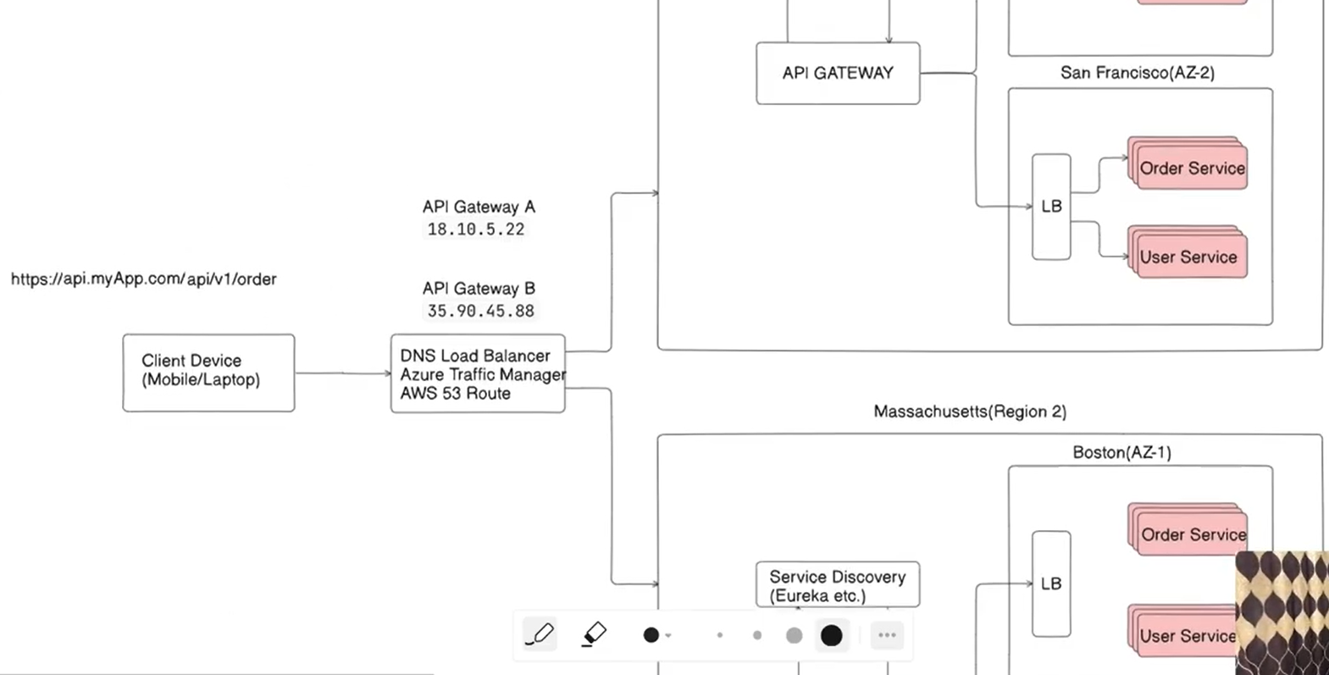
- The client sends out the request to the DNS load balancer, which returns the IP address of the API gateway closest to the client based on its region.
- The API gateway will then ask the Service Discovery to return the IP address of the closest AZ’s (Availability zone) load balancer, and it will send the client’s request to that load balancer.
- Then this LB will route the request to the available microservice instance based on traffic and health checks.
- In case AZ-1 goes down, then the Service discovery will return the IP address of AZ-2’s load balancer, and in case if an entire region goes down then the DNS load balancer will return the IP address of region-2’s LB.

LOAD BALANCERS
- Types of Load Balancers
  - L4:
    - Operates in the Transport layer (OSI model)
    - Uses protocols like TCP and UDP
    - It only cares about three things
      - Source IP address and port
      - Destination IP address and port
      - Protocol (TCP or UDP)
    - It takes the request from the client and routes it to a microservice instance based on availability.
    - It doesn’t care about what the request is for, all the logic is handled by the server/microservice instance, i.e., the server will handle whether the request is to create a room or send a message or view user profile, etc.
  - L7:
    - Operates in the Application layer (OSI model)
    - Understands HTTP headers, websockets, etc.
    - It routes the request to different microservice instances based on what the request needs, like if the request is user/v1/updateprofile then it will be routed to the available user microservice by L7 LB.
- LB Algorithms
  - Static Algos
    - Round Robin
      - Routes requests equally to all servers in a round robin style, i.e., if there are 2 servers then user 1 will be routed to server 1, user 2 to server 2, user 3 to server 1, user 4 to server 2, and so on.
      - It is problematic when the servers are of unequal capacities, as then few servers will stay underutilized and few will get overutilized.
    - Weighted Round Robin
      - Servers are assigned weights based on their capacities (the one with a higher capacity gets a higher weight)
      - Incoming requests are routed based on weights, like in above example of 2 servers, if server 1 is given a weight of 3 and server 2 is given a weight of 1, then user 1,2,3 will be routed to server 1 and user 4 will be routed to server 2, and again user 5,6,7 will be routed to server 1 and user 8 will be routed to server 2.
      - It is problematic when the heavy requests are routed to the lighter server and light requests are routed to the heavier server. Like in above example if request 1,2,3 take 10ms each and request 4 takes 10s, then load on server 2 will increase while server 1 will stay underutilized.
    - IP hash
      - Not any better than Weighted round robin
      - Uses a hash function and calculates the hash value of user IPs and if there are n servers, then requests are routed based on hash(IP)%n
      - It gets problematic when a proxy server is placed before the load balancer, as then the LB thinks each request is coming from the same IP and it routes each request to the same server.
  - Dynamic Algos - distribute traffic in real time based on server load and performance metrics
    - Least Connections
      - A new TCP connection is established with the server that has the least connections.
      - This does not ensure that traffic is also distributed, for instance the users who send requests very frequently are connected to a weak server, then the heavy server would stay underutilized.
    - Weighted least connections
      - Servers are assigned weights based on their capacities. A powerful server is assigned a higher weight.
      - Then connection to weight ratio is calculated and the server with least ratio is given the new connection.
      - One disadvantage of this algo is that it does not consider the complexity of the incoming request, only the connection count is considered.
    - Least response time
      - TTFB (Time to first byte) is the total time taken between a request and first response from the server.
      - TTFB is calculated for each server and it is multiplied by the number of connections to get a value for the server
      - The server with the least value gets the new connection.
      - As the connections increase, the value also increases and load shifts to another server.

PROXY SERVERS
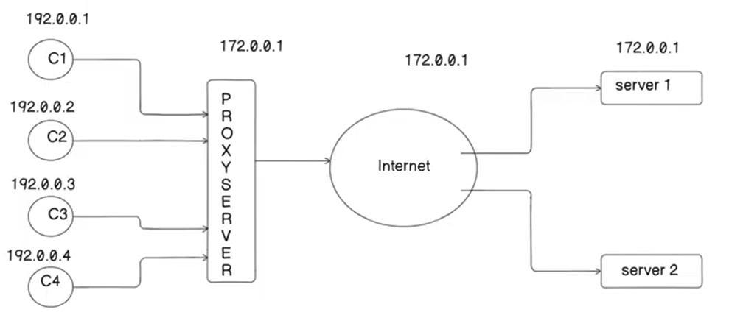

There are two types of proxy servers:
- FORWARD PROXY SERVER: it lies between the client and the internet. Its features are:
  - Provides anonymity to the client: The client sends the request to the proxy server using its own IP address, but the internet receives that request from the proxy server’s IP, so the client stays anonymous.
  - Enables access control: enterprises use proxy servers to restrict access to various sites, like if a user in a company is not allowed to visit chatgpt, so when he sends a request to this site, the proxy server blocks the access.
  - Groups request together: If 4 users simultaneously send a request to view a file, it will group those requests and will serve the same copy to all of them. So the origin server only processed the request once and results were cached in the proxy, hence reducing the load on the proxy server.
  - Enables access to restricted content: If your IP is restricted to access some content, you can access it using the proxy server’s IP.
  - Caching: client visits google.com, then the proxy server stores this information that the client visited this site and if the client visits it again, the proxy shows the cached response to the client.
- REVERSE PROXY SERVER: it lies between the internet and application server. Its features are:
  - Provides IP anonymity to application servers. For instance, if a reverse proxy is placed between facebook’s server and internet, then the internet would never know facebook’s actual IP address.
  - Can be used as a load balancer.
  - Also helps in caching.
  - Protects the server from DoS attacks.

Difference b/w proxy and VPN: VPN encrypts the data and then the data gets decrypted on the application server, whereas Proxy provides IP masking.

Proxy Server v/s Load Balancer: Load balancing is just one feature of a proxy server, i.e., a proxy can act like an LB, but LB cannot act like a proxy.

Why do we need LBs then: for very large applications which get very high traffic we keep proxy and LB separate to implement separation of concerns. A LB is purposefully built to manage high traffic, perform health checks, etc.

CACHING:
- Types of Caching
  - Local Caching:
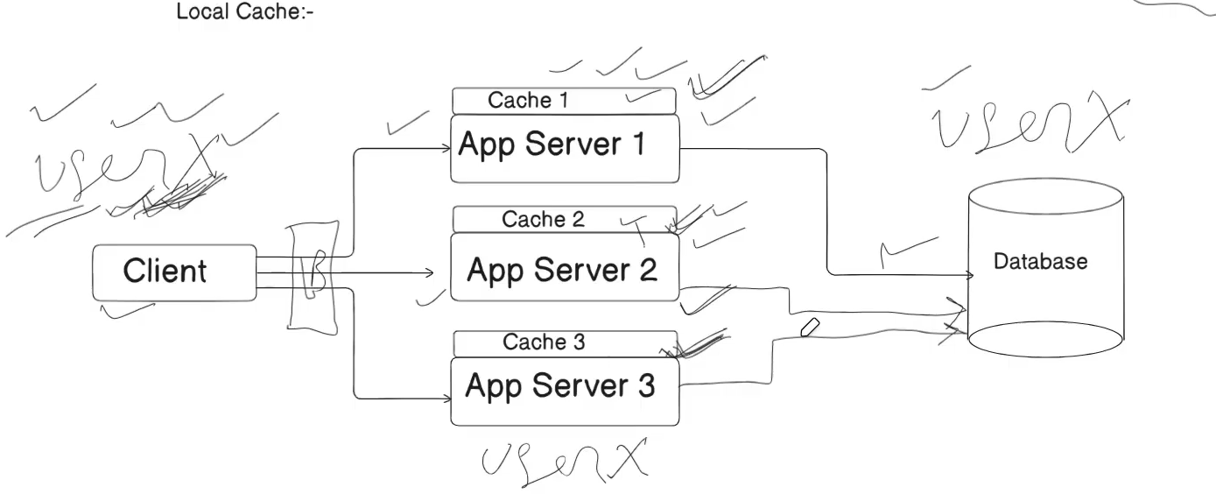

- It is fast but it might increase data inconsistency, as the cache would get updated in one server but it would take time to reflect that update in all the servers.

- Distributed Caching:
  - It solves the problem of data inconsistency as data is stored in a single place.
  - It involves one more network and hence it is slower.

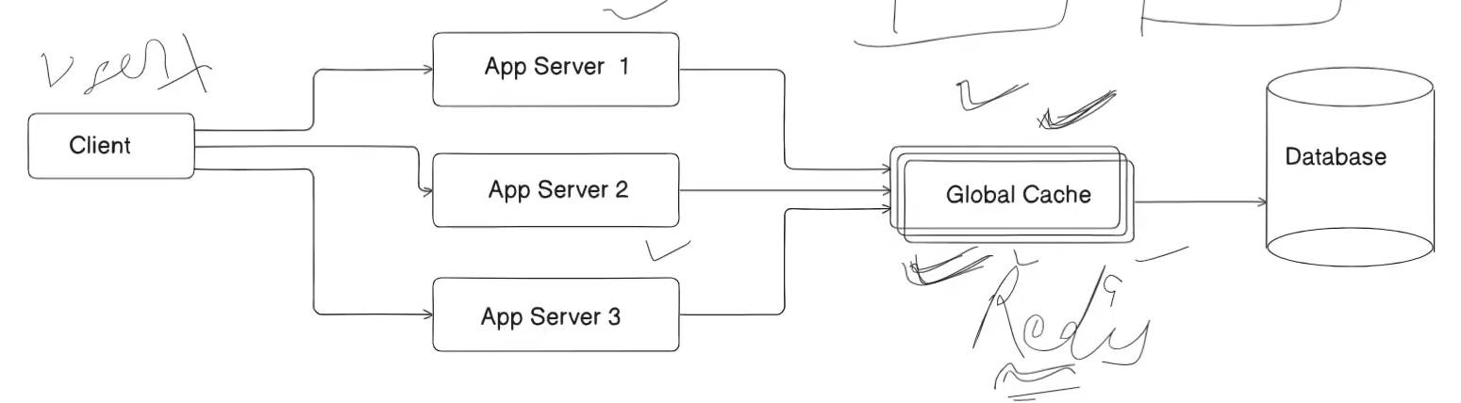

- Caching Policies:
  - Cache Eviction Policies
    - FIFO Cache:
      - First-in First out - A, B, C are present in the cache, we wish to add D, so A will be removed as it came first
      - One problem in this approach is that it doesn’t care about the access frequency, like A would have been getting used every hour and B was getting used every 5 days, then too it will remove A.
    - LRU Cache:
      - Least recently used cache: the piece of memory that was used least recently is pushed out
    - LFU Cache:
      - Least frequently used piece of memory is pushed out
  - Cache Write Policies
    - Write Through:
      - Users updates data -> goes to Cache
      - Cache writes immediately to DB
      - Both Cache and DB are always in sync.
    - Write Back:
      - User updates data -> goes to Cache
      - Cache acknowledges success immediately
      - Cache writes changes to DB later in the background
      - Here the updates are very fast but data becomes inconsistent for a while.

DISTRIBUTED SYSTEMS:
- Multiple computers work together to perform a task, but to the user it appears as if a single computer is performing the required task.
- Horizontal scaling, Availability zones, Load balancers, etc are part of a distributed system.
- Advantages:
  - Scalability
  - Fault tolerance
  - Low latency
CONTENT DELIVERY NETWORK (CDN):
- A CDN is a network of servers placed in different locations around the world
- It stores copies of static website content (like images, videos, and pages)
- When you open a website, it loads from the closest server to you, not the original one.

RATE LIMITING:
- It is used when a user starts exploiting the server’s resources by sending multiple requests in a very short time frame, and because of that the genuine users are not able to send requests to the server as the server’s resources get busy.
- To tackle this, we use a rate limiter, that puts a limit to the number of requests a particular user can send in a particular time interval, for instance, 3 requests / user / min, and if the user exceeds this limit, we can return a 429 error (too many requests).
- RATE LIMITING ALGORITHMS:
  - TOKEN BUCKET ALGORITHM:
    - It is a rate-limiting algorithm where tokens are added to a bucket at a fixed rate, and each request consumes one token.
    - If tokens are available, the request is allowed; if not, it is rejected or delayed until tokens refill.
    - It allows short bursts of traffic since unused tokens can accumulate, for example, with capacity = 5 and refill rate = 1 token/sec, you can send 5 requests instantly after idle time, then only 1 request per second afterward.
    - Advantages: Handles bursts smoothly, flexible (separate burst size and rate control), and prevents system overload.
    - Drawbacks: Slightly complex to implement, allows sudden spikes, requires maintaining state (tokens + time), and is harder to scale in distributed systems.
  - LEAKY BUCKET ALGORITHM:
    - Similar concept, the bucket will have a capacity (lets say 2000 requests) and it will have a leakage rate which would depend on the server’s capacity (lets say 100), and the users would keep sending requests until the bucket is full, and once the bucket is full, the user would not be able to send any more requests.
    - The bucket would send 100 requests per second to the server (leakage) and this way the users would be able to send 100 more requests every second.
    - Advantages: doesn’t allow burst requests
    - Drawbacks: wait time increases when the bucket is full and the leakage rate is low
  - FIXED WINDOW COUNTER ALGO:
    - Only a certain number of requests are allowed in a specific time interval, like 3 requests/sec, so each second the counter resets to 0 and keeps on counting the incoming requests, once it exceeds the fixed limit, it stops processing them, and when the time interval ends, the counter again resets to 0 and it starts processing the requests again.
    - Drawback: Considering the above example of a fixed limit of 3 and 1 second interval, lets assume we processed two requests in 1.5 to 2 seconds and two requests in 2 to 2.5 seconds, so technically we didn’t exceed the fixed limit, but if we look at the window 1.5 to 2.5 second, we exceeded the fixed limit.
  - SLIDING WINDOW LOG ALGO:
    - We maintain a request log, that stores the timestamps of incoming requests, as the window slides forward, the older requests are removed from the log, and the newer ones are added, but the ones that exceed the fixed limit are rejected and processed only when space is available in the log.
  - SLIDING WINDOW COUNTER ALGO:
    - In Fixed window counter algo, the window jumps abruptly when the time increases its far end, and the counter resets, whereas in Sliding window counter algo, the window slides gradually and the counter decreases for the requests that went out of the window and increases for the ones that entered the window, for example if the window moved 10%, then we will take 10% from new interval and 90% from old interval, and count the total requests to check if they are exceeding the counter.
    - This algo is more accurate than fixed window counter algo and consumes less memory than sliding window log algo.
SSL CERTIFICATES:
- Data transfer in HTTP takes place in unencrypted form, i.e., in the form of plain text. But in this case there’s a risk of any third party accessing our data.
- So we use encryption. We encrypt the data on client side and decrypt it at server side using the same key, and this is called symmetric encryption, but this requires both the parties to have the key in advance.
- Symmetric encryption is problematic because we need to send the key and data both, and if the hacker sniffs out both, then he will get access to our data.
- The solution to this problem is asymmetric encryption. Below is its flow:
  - The server has a public key and private key
  - The server shares its public key to the client, the hacker might also receive it, which is fine.
  - Then the client encrypts its symmetric key using the server’s public key and sends it to the server. It can only be decrypted using the server’s private key, so the hacker cannot access it.
  - Then the client sends the data encrypted using its symmetric key, and the server decrypts it without any data leak.
  - It can be problematic when the hacker acts as a proxy in front of the server. The hacker replaces the server’s public key with its own public key, and the client thinks that it's the server’s public key and sends its symmetric key to the hacker.
- Its solution is using a SSL (Secure Sockets Layer) certificate. Below is its flow:
  - A third party provides a SSL certificate to the server. Basically, the third party (like GoDaddy) takes its own public key and encrypts the server’s public key and generates a signature, and puts this on a certificate which contains the domain name, server’s public key, and this signature.
  - When the client receives the server’s public key, it takes GoDaddy’s public key and generates the signature and verifies if it's the same as that on the certificate.
  - The hacker cannot act as a proxy here because its public key will not generate the same signature.
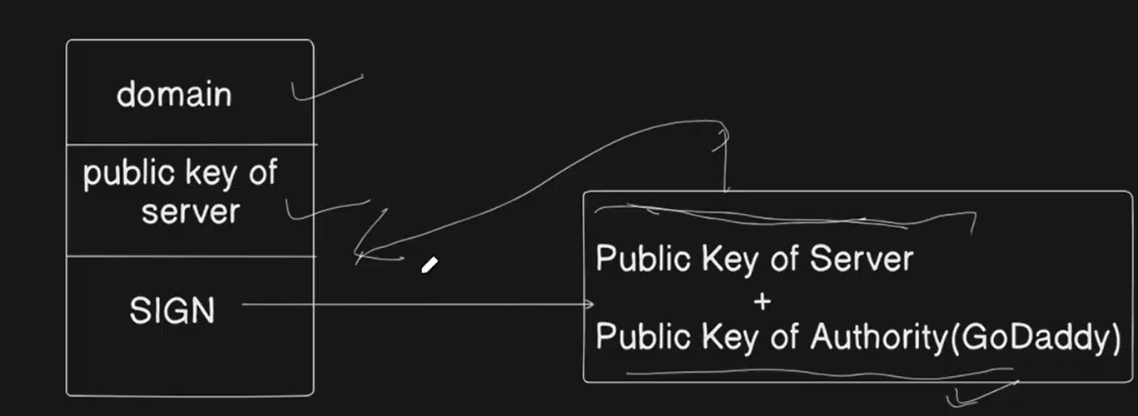

DATABASE DESIGN TIPS:
- Choice of the database depends on the following factors:
  - Structure of the data (fixed structure or unstructured).
  - Query pattern (joins, ACID properties, key-value pair, etc).
  - Amount of scale we need to handle (RDBMS works well with small scale, NoSQL is better for large scale).
- CACHING SOLUTIONS:
  - Reduces access time of frequently required data.
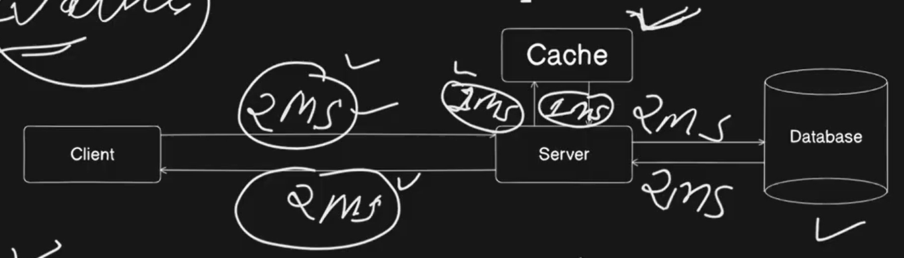
  - In case of a remote call too, we will use Caching as it will reduce the latency. Redis can be used for Caching (key-value data store).
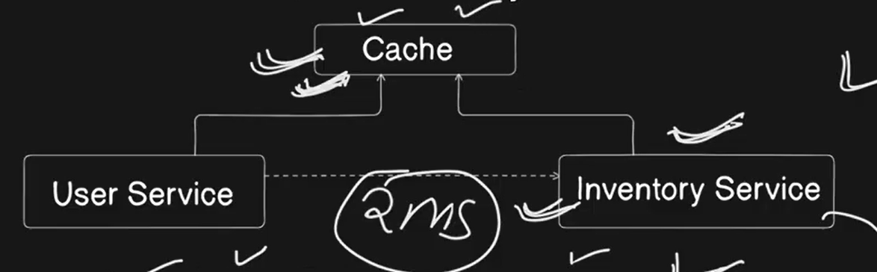
  - To store static data (image, audio, video) we use blob storage, like Amazon S3. For instance, if the S3 storage of Netflix is hosted in the USA, then the latency of users in India will increase, and to tackle this problem we use CDN. We host multiple CDNs according to the user base in different regions, and in case if a user requests some data that is not present in its own region, the request is redirected to the next nearest CDN.
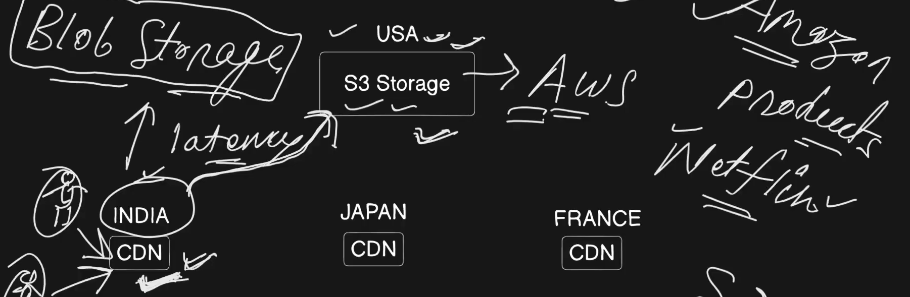

- SEARCH FUNCTIONALITY
  - We use text search engines like Elastic Search to implement Search Functionalities. It is based on Apache Lucene, which is a high performance text search library written in Java.
  - It provides functionalities like Fuzzy searching (searching misspelled words), auto complete, etc.
  - A database guarantees that the data would not get lost, but Elastic Search does not guarantee that, it is designed for speed and write operation in the node takes place in a while after inserting the data.
  - An Elasticsearch cluster cannot store the availability of items, so we need to call the inventory service to check availability.
SINGLE POINT OF FAILURES
- Components can be avoided to become single point of failure using the following methods:
  - Load balancer - use multiple load balancers
  - Server: scale out your application and add multiple servers
  - Database: use master-slave architecture and implement data replication
  - Cache servers: add multiple cache servers
  - Data center: add multiple data centers to create an availability zone
  - Availability zone: Add multiple AZs to create a region
  - Region: Add multiple regions to distribute users and avoid SPOFs

MESSAGE QUEUES:
A message queue is a communication mechanism that enables different parts of a system (maybe services) to send and receive messages asynchronously.

Problems with synchronous communication are:
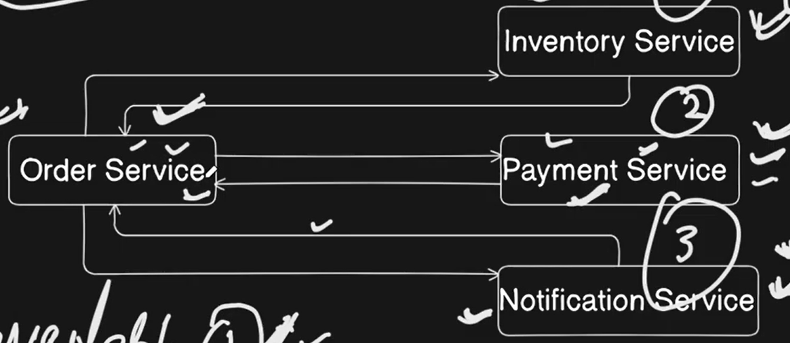
- Availability: Inventory service should always be available for order service to receive messages.
- Response delay: If Payment service is taking longer to process the request and send a response, the entire system will have to wait for it before processing any further requests.
- Data Loss: Order service sent a message to Inventory service, but it got crashed at the same time, so the data gets lost as order service would think that Inventory service have received the message.

How message queues solve these problems:
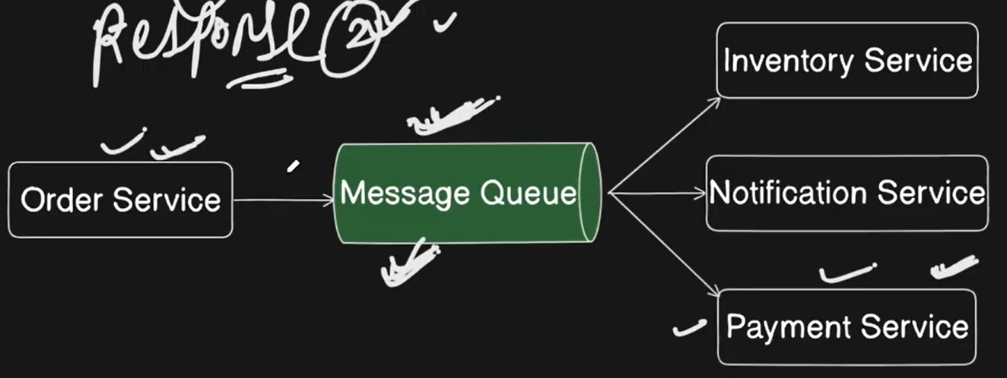

- Availability: The order service will just add its request in the message queue, and it does need the inventory service to be available.
- Response delay: The order service will simply add the payment request in the message and will start working on other tasks without waiting for the response, and the payment service will pick up this request from the message queue when it's available.
- Data loss: Data will not get lost if any of the services goes down as the data is stored in the Message queue.
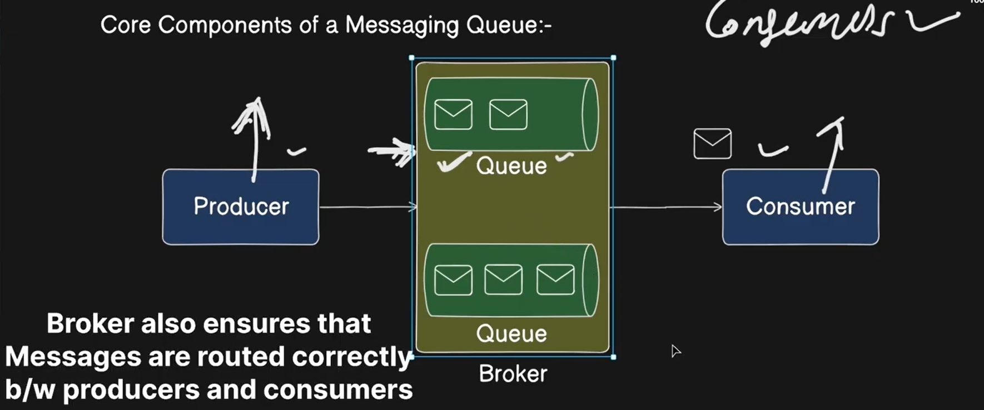
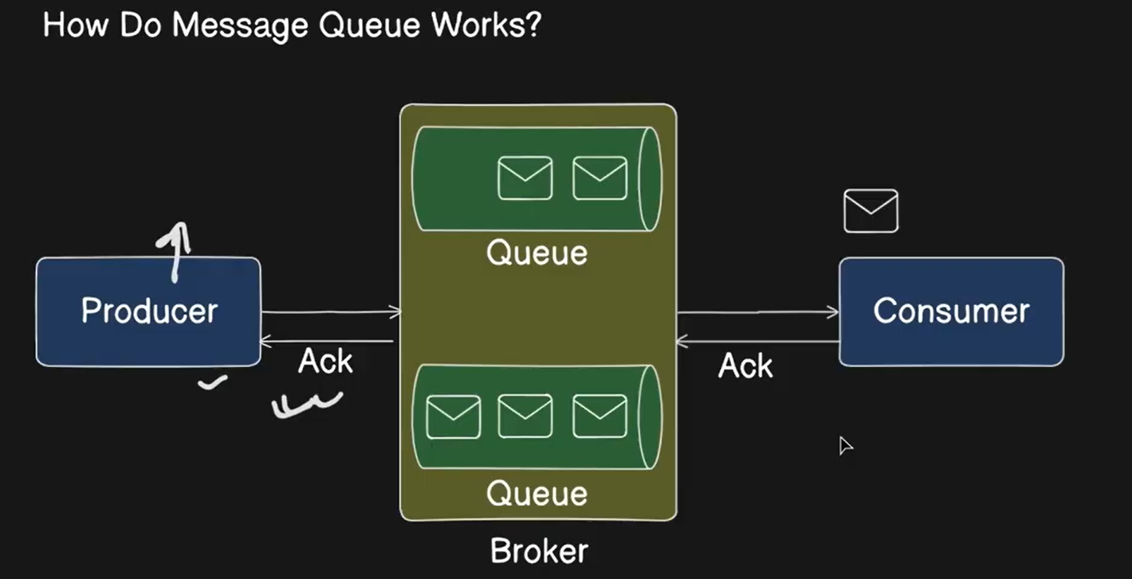

- The producer generates a message, which is called message creation.
- Then the producer sends the message to the broker, which adds it to the queue and acknowledges the same.
- The consumer consumes that message and sends an acknowledgement to the broker, and the broker removes that message from the queue on receiving the acknowledgement.

Types of message queues:
- POINT-TO-POINT MESSAGE QUEUES (RabbitMQ):
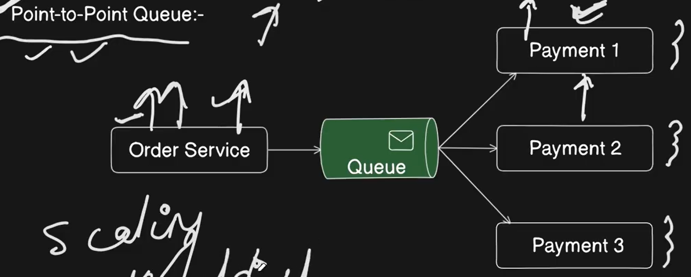
  - They operate on the Producer-Consumer model, which states that there will only be a single producer and a single consumer, and there can be multiple instances of the consumer, which are called competing consumers.
  - They can be used for scaling, rate limiting and workload distribution.
- PUBLISHER-SUBSCRIBER QUEUE (Kafka):
  - Single publisher and multiple subscribers.
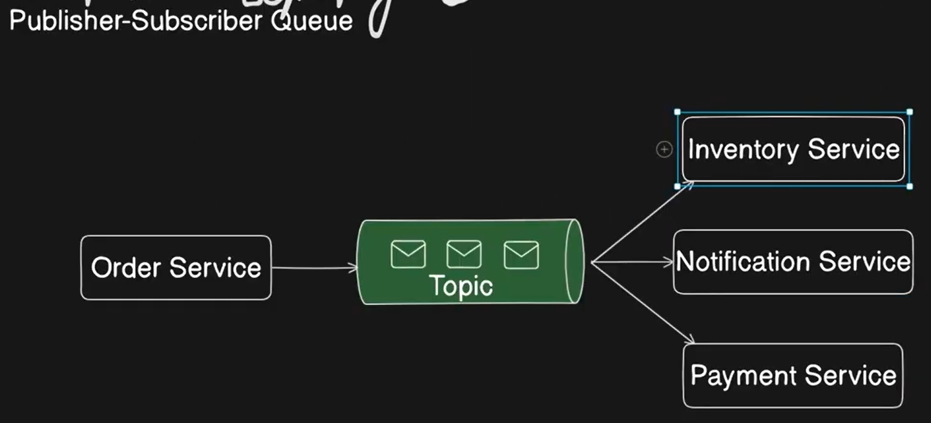

(How do RabbitMQ and Kafka operate together):
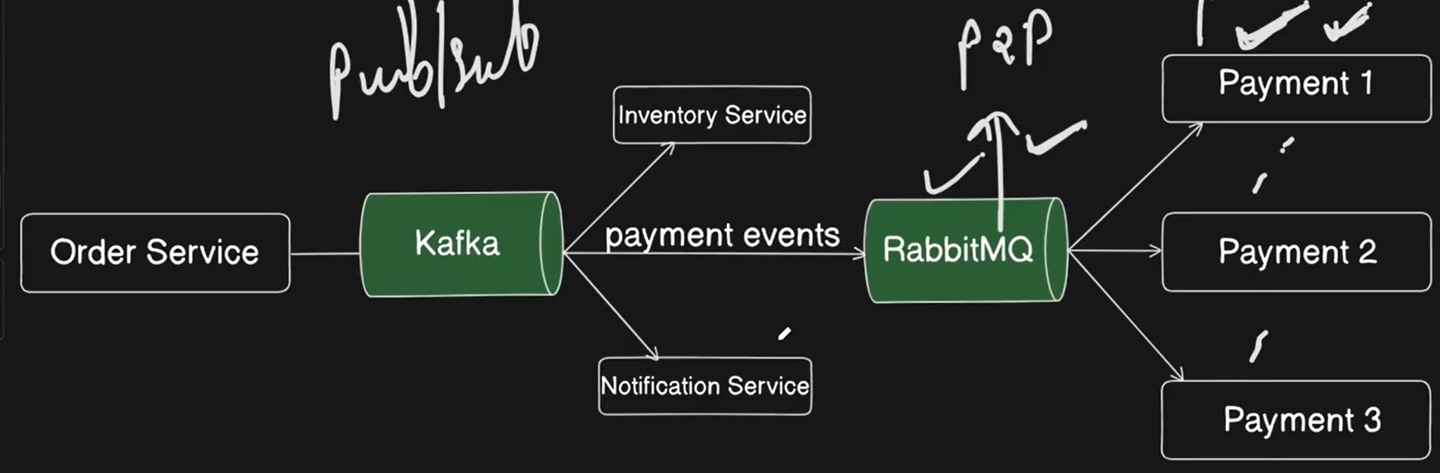

- PRIORITY QUEUE: We simply define the priority of messages and the one with a higher priority is executed first.
- DEAD LETTER QUEUE: The messages that failed to execute or went into error are pushed into this queue.

CONSISTENT HASHING:
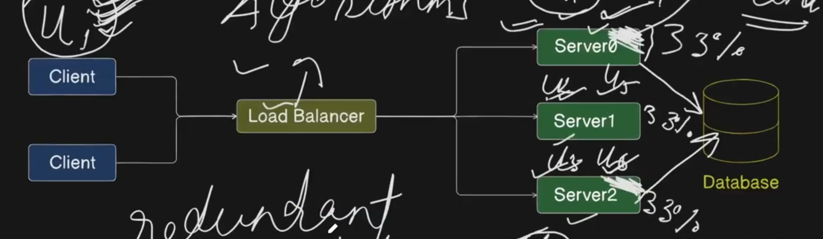
When the user U1 first sent a request, it got redirected to Server0 by the LB and that server cached its profile, but when it came back again after some time, the LB redirected it to Server2 but its profile was not cached there, so either we would cache its profile again which will cause redundancy, or we would access it from the database, which would increase response time. To solve this problem, we use request stickiness, that is, a specific user’s request should be redirected to the same server every time, and we achieve this using hashing.
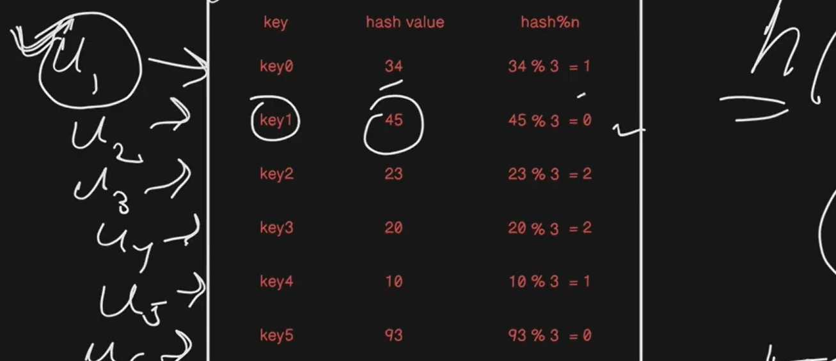
The Hash function generates a hash value for the user’s key and we mod this hash value with the number of servers, and this gives us the server index to which the request should be routed.

The problem comes when we add another server, as then the hash%n value will change for all the users, which would give us a lot of cache misses (when required data is not available in the cache), so we cannot use hashing here, and hence we use consistent hashing.

In consistent hashing, the hash function generates values X0 to Xn (n -> number of servers) for all the servers and keys, and if we arrange the numbers X0 to Xn in a circular manner, we get a ring-like structure.
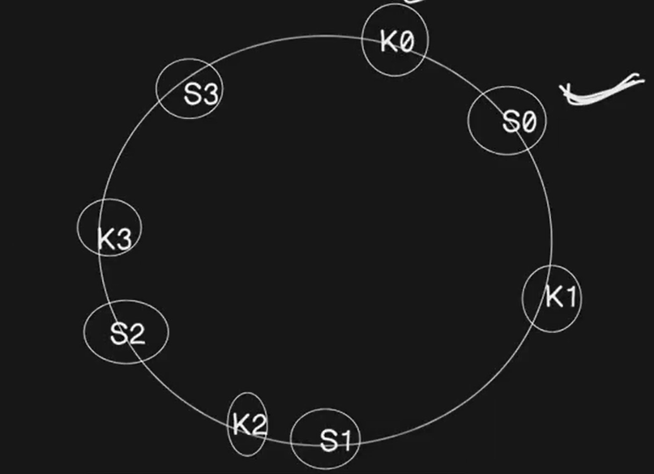
And we move clockwise from every key in this ring to assign servers to keys, and this way the load is distributed in this structure.

Now suppose we added a new server and its hash value came in between K1 and S1, and earlier K1 was being assigned to S1, but now it's getting assigned to S2.
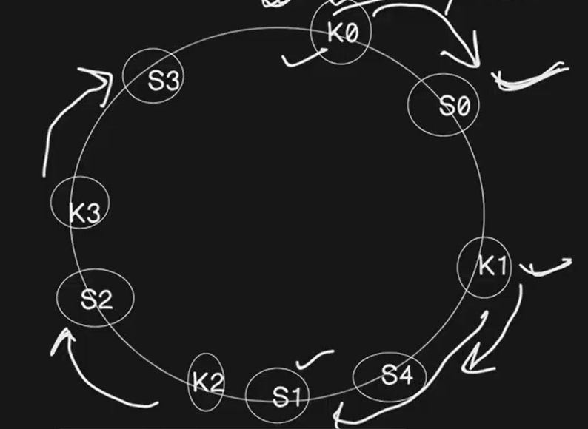
So we will have to rearrange the keys between S0 and S4, as they will now get assigned to S4. But we were required to do the same rearrangement in hashing, how’s this better? Its better because we only need to rearrange a fraction of keys here, and not all of them. In hashing we were required to rearrange all the keys.

One problem that occurs in consistent hashing is accumulation of servers on one end of the ring, which is tackled using virtual server nodes, so that load gets distributed equally. A virtual node is nothing but a pointer to the server’s address.
